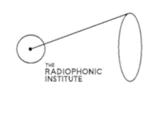
The Estuary Sound Ark
Youth Generators Application Form

Name:
Location:
Email address:
Contact phone number:
Tick box to confirm you are between the age of 18 – 25 years old.
How did you find out about this opportunity?

What areas of the creative industry are you passionate about? This could be visual arts, music, theatre, writing, digital arts, sound, film, or others. Please include a few examples of projects or artists that you enjoy.

What is it about The Estuary Sound Ark project that you are most interested in?

Are you available for the initial workshop on Wednesday 15th June at Chatham Historic Dockyard?

Do you have any access requirements?

Please return your completed application form via email to regen2031@kent.ac.uk by 5pm on Tuesday 7th June.

